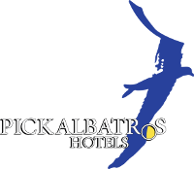**New Year Program**

**Day Time Color Festival Beach**

**18:00-18:30 Soft Music Lobby bar**

**18:00-18:30 Cocktail Reception Lobby bar**

**18:30-21:30 Opening of the restaurant with soft music Restaurant**

**20:00-20:35 Mini Disco Tent**

**20:35-21:20 Singer duet Tent**

**21:20-21:50 Animation Show Tent**

**21:50-22:10 Magic Show Tent**

**22:10-22:30 Live Singer Tent**

**22:30-23:00 International Show Tent**

**23:00-23:20 Latin Show Tent**

**23:20-23:40 Animation Show Tent**

**23:40-23:59 DJ with Go-go Dancer Show Tent**

**23:59-00:00 Countdown Happy new year Tent**

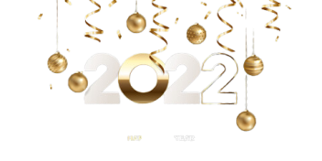**00:00 DJ Music Tent**