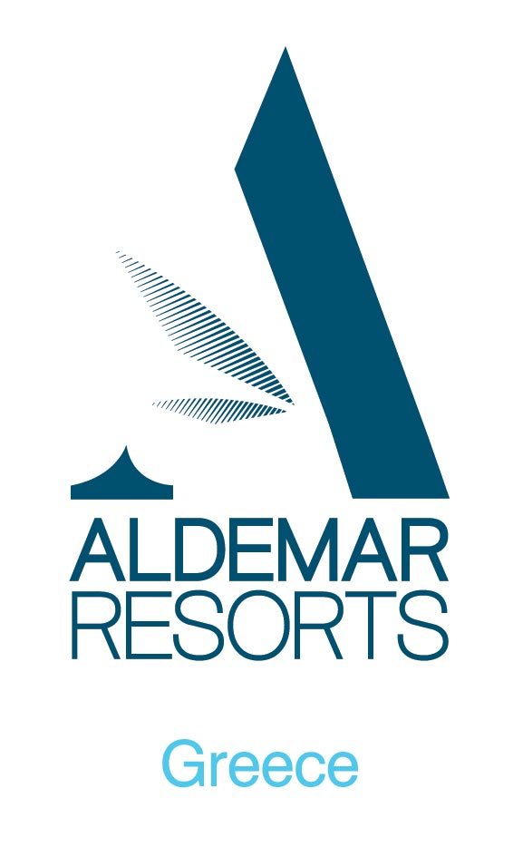

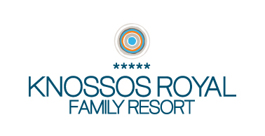

PREMIUM
ALL-INCLUSIVE PROGRAM

BREAKFAST
Main Restaurant | Early breakfast to be ordered in advance | Continental
Main Restaurant | 07:00 - 07:30 | Continental
Main Restaurant | 07:30 – 10:00 | American Style buffet
Snack Bar | 10:00 – 11:15 | Late Breakfast continental

ANIMATION – SPORTS ACTIVITIES
All inclusive water sports canoe, pedalo, windsurfing (depending on weather conditions) – free of charge only for valid certificate holders. (Reservation required)

GENERAL NOTES FOR THE AI PROGRAM
- Some departments or services may operate periodically depending also on weather conditions.
- Juices are not fresh.
- Local alcoholic drinks: raki, ouzo, brandy.
- Local & international spirits (except champagne): liqueur, gin, vodka, rum, tequila, whiskey, sparkling wine. All drinks are mentioned in the list of each department.
- Every guest can take only 2 drinks each time.
- For safety reasons, drinks around the pools and beach, must be served in polycarbonate glasses (not glass).
- Underage children (younger than 18 years old) are not allowed to consume alcohol.
- No food and drinks may be taken outside the hotel’s departments areas.
- Smoking is prohibited in the internal areas of all restaurants, bars and common domains of the hotel.
- Formal dress (no shorts, sleeveless T-shirts etc) is required in all restaurants – bars during dinner (Bermuda trousers exceptionally allowed)
- Wearing an all inclusive bracelet is obligatory in order to be served. The bracelet must be returned to the reception upon departure. Lost bracelets must be reported to the reception immediately in order to receive a new one against charge.
- All other services as from the main hotel description
- All information on this sheet is subject to change for operational reasons without prior notice

LUNCH
Beach Restaurant  Self service- Buffet  (15/5 – 30/9), upon reservation, once per stay for minimum 4 days stay | 12:30 – 15:30 | Buffet lunch: Salads, dressings, hot & cold appetizers, main coursed, selection of desserts, ice-cream and fresh fruit | Drinks included: water, glass of wine, beer, soft drinks, juice
Snack Bar (self service) | 12:30 – 15:30 | Salads, dressings, hot dishes selection of desserts, ice-cream and fresh fruit | Drinks included: water, glass of wine, beer, soft drinks, juice
DINNER
Main Restaurant (buffet)  2 theme buffets weekly | 18:30 – 21:15 | Salads, dressings, hot & cold appetizers, main courses, show cooking, selection of desserts, ice-cream and variety of fresh seasonal fruits | Drinks included: water, local wine, beer, soft drinks, juice
Taverna Artemis  (upon reservation once per stay / for minimum 4 days stay) | 19:00 – 22:00 | Set Menu (table service) | Drinks included: mineral water, local wine, Greek beer, soft drinks, juices, coffee, tea (table service)
Beach Restaurant Dinner (upon reservation once per stay for minimum 4 days stay) 15/05-30/09 | 19:00 – 22:00 | 4 Course Menu (served) | Drinks included: mineral water, local wine, Greek beer, soft drinks, juices (table service)

BARS
MANITARI BAR 10:30 – 17:30
Drinks included: Filter coffee, espresso and cappuccino, instant coffee, water, soft drinks, tea, glass of wine, draught beer, fruit juice, Metaxas, ouzo, raki international alcoholic drinks. Selection of ice-cream and granite (2 flavors)  Not included: Premium Brands, Champagne and Cognac | Coffee Time (11:15 – 12:30 & 16:30 – 17:30)  Filter coffee, espresso and cappuccino, instant coffee, Greek coffee, water, soft drinks, tea, fruit juice, selection of pastries and cakes (self service)  Snack Time (15:30 – 16:30)  Variety of snacks (self service)
SNACK BAR 10:00 – 17:30
Drinks included: water, soft drinks, draught beer, glass of wine, fruit juices | Coffee Time (11:15 – 12:30 & 16:30 – 17:30)  Filter coffee, espresso and cappuccino, instant coffee, Greek coffee, water, soft drinks, tea, fruit juice, selection of pastries and cakes (self service)  Snack Time (15:30 – 16:30)  Variety of snacks and ice cream (self service)
POOL BAR 10:30 – 17:30
Drinks included: Filter coffee, espresso and cappuccino, instant coffee, water, soft drinks, tea, glass of wine, draught beer, fruit juice, Metaxa, ouzo, raki, international alcoholic drinks. Selection of ice-cream & granita (2 flavors)  Not included: Premium Brands, Champagne and Cognac | Coffee Time (11:15 – 12:30 & 16:30 – 17:30)  Filter coffee, espresso and cappuccino, instant coffee, Greek coffee, water, soft drinks, tea, fruit juice, selection of pastries and cakes (self service)
MAIN BAR 18:00 – 00:00
Drinks included: Filter coffee, espresso and cappuccino, instant coffee, water, soft drinks, tea, glass of wine, draught beer, fruit juice, Metaxa, ouzo, raki, international alcoholic drinks. | Not included:  Premium Brands, Champagne and Cognac
KAFENIO 17:30 – 22:30 (15/05-30/09): Ouzo, raki, wine, beer, water, soft drinks, tea, Greek coffee, Metaxa, international & local spirits
OPEN DISCO (June – Sept) 22:30 – 00:00 (occasionally) at the Main Bar
BEACH PARTY 21:00 – 00:00 (June – Sept) every week with listed drinks
SPECIAL EVENTS ARE ON EXTRA CHARGE

CREDIT CARDS ACCEPTED
Access, American Express, Diners, Eurocard, Mastercard, Visa

COMMUNICATION
ALDEMAR Knossos Royal - Family Resort  Limenas Hersonissou 700 14  Crete, Greece  Tel.:+30 28970 27400, Fax: +30 28970 23150  e-mail: kr@aldemar.gr  www.aldemar-resorts.gr | ALDEMAR RESORTS Head Office  262 Kifissias Ave. Kifissia 145 62  Athens, Greece  Tel.:+30 210 62 36 150, Fax: +30 210 80 17 451  e-mail: sales@aldemar.gr  www.aldemar-resorts.gr

